ER Diagram

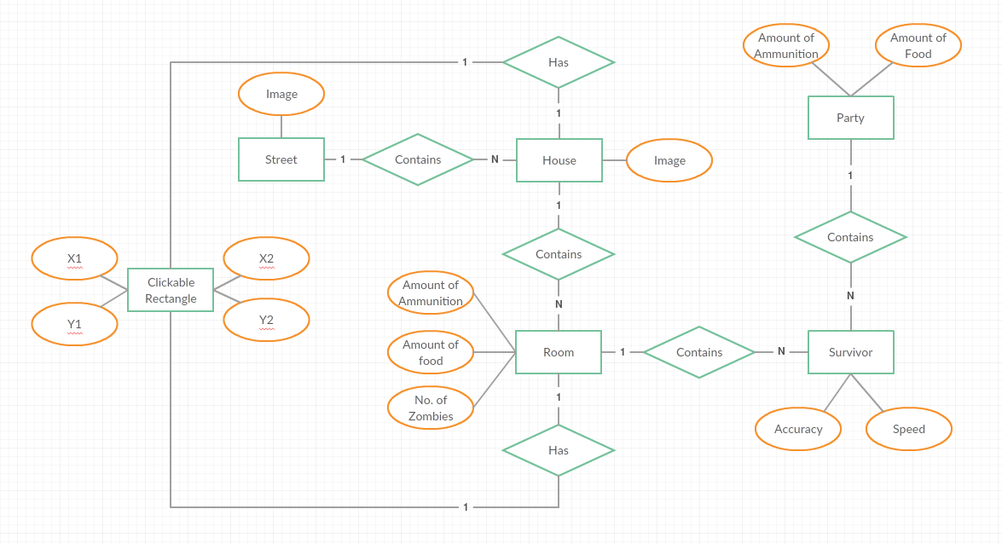

- Street
  - Image – The location of the image used to represent the street's view
- House
  - Image – The location of the image used to represent the house's view
- Room
  - Amount of ammunition – The number of items of ammo in the room
  - Amount of Food – The number of cans of food in the room
  - No. of Zombies – The number of zombies in the room
- Survivor
  - Accuracy – The survivor's accuracy (determines their skill at killing zombies)
  - Speed – The survivor's speed (determines their ability to run from zombies)
- Party
  - Amount of Ammunition – The party's ammo cache
  - Amount of Food – The party's food stock
- Clickable Rectangle – Defines a rectangle that is a clickable region in the image
  - X1, Y1 – The first corner of the rectangle
  - X2, Y2 – The opposite corner of the rectangle

